Unit 2 Exam-Style Questions

1. (a) The electronic structure of a sodium atom can be written 2,8,1.
Write the electronic structure of a potassium atom in the same way.

.....................................................................................................................................
(1)

(b) The electronic structure of a sodium atom can also be represented as in the
diagram below.
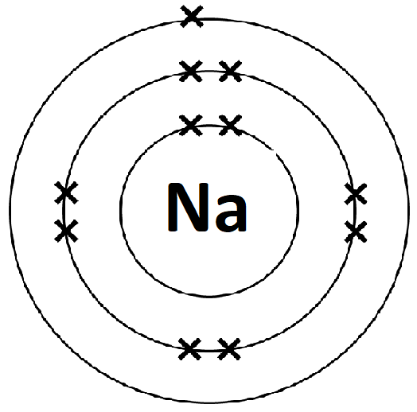

Draw a similar diagram for a fluorine atom.

(3)

(c) Describe, in as much detail as you can, the structure of a fluorine atom.

.....................................................................................................................................

.....................................................................................................................................

.....................................................................................................................................

.....................................................................................................................................
(3)

2. (a) Complete the diagram to show the electronic structure of a magnesium atom.
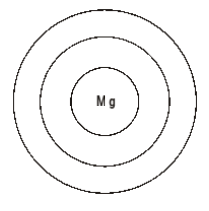
(2)

(b) Write the electronic structure of a magnesium atom.

.....................................................................................................................................
(1)

(c) Use the diagram and your answer to part (a) and (b) to answer the following
questions.
(i) In what group of the Periodic Table is magnesium?
.....................................................................................................................................
(1)
(ii) Explain your answer

.....................................................................................................................................

.....................................................................................................................................

(1)

(iii) In what period of the Periodic Table is magnesium?
.....................................................................................................................................
(1)
(iv) Explain your answer

.....................................................................................................................................

.....................................................................................................................................

(1)
(d) Explain what is meant by the numbers in the symbol 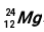

.....................................................................................................................................

.....................................................................................................................................

3. (a) The diagram represents an atom of an element.
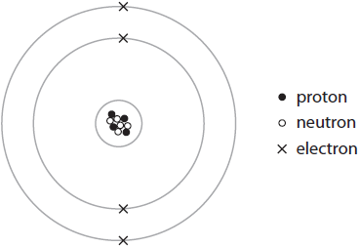
Use numbers from the box to complete the table. You may use each number once, more than once or not at all. (4)

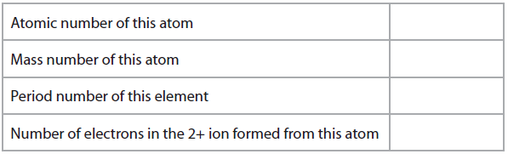

(b) In terms of sub-atomic particles, state a similarity and a difference for isotopes of the same element.
(2)
similarity
.............................................................................................................................................
.............................................................................................................................................
difference
.............................................................................................................................................
.............................................................................................................................................

4. (a) State the meaning of the term atomic number.
(1)
.............................................................................................................................................
.............................................................................................................................................

(b) An atom of element X contains 14 protons, 14 electrons and 15 neutrons.
(i) Which of these is the mass number of this atom?
(1)
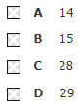

(ii) Explain which group of the Periodic Table element X belongs to.
(2)
.............................................................................................................................................
.............................................................................................................................................
.............................................................................................................................................
.............................................................................................................................................
(c) The table shows the composition of a sample of a different element, Y, containing three isotopes.
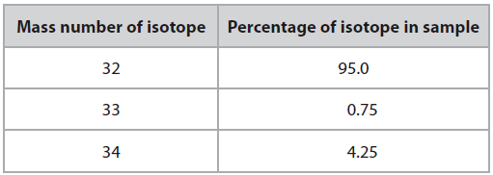
Using information from the table, calculate the relative atomic mass (Ar) of this sample of element Y. Give your answer to one decimal place.
(3)

Ar = ...........................................................

5. The diagram represents an atom of an element.
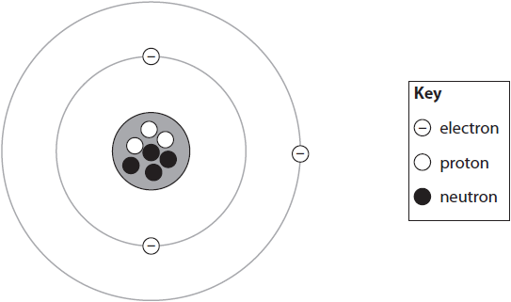
(a) Use information from the diagram and the Periodic Table to answer these questions.
(i) Give the atomic number of the atom.
(1)
.............................................................................................................................................
(ii) Name the part of the atom that contains protons and neutrons.
(1)
.............................................................................................................................................
(iii) Give the group in the Periodic Table that contains this element.
(1)
.............................................................................................................................................
(iv) Give the period in the Periodic Table that contains this element.
(1)
.............................................................................................................................................
(v) Give the name of this element.
(1)
.............................................................................................................................................
(vi) Give the charge on the ion formed from this element.
(1)
.............................................................................................................................................
(b) A sample of the element contains two isotopes, X and Y.
(i) Explain what is meant by the term isotopes.
(2)
.............................................................................................................................................
.............................................................................................................................................
.............................................................................................................................................
.............................................................................................................................................

(ii) The table shows the mass number and percentage abundance of each isotope in this sample of the element.
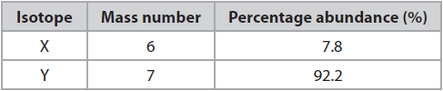
Calculate the relative atomic mass (Ar) of the element.
(2)

Ar = ...........................................................

7. This question is about substances with covalent bonds.
(a) Draw a dot and cross diagram to show the outer shell electrons in a molecule of nitrogen, N₂
(2)

8. Use the words below to complete sentences A, B, C and D

forces giant structure melting point molecular structure molecule

A A structure made up from separate molecules is a ________________
B A structure in which all of the particles are joined together in one huge piece is a
_______________________________
C Substances made from __________________________ are often gases because
there are weak _____________ of attraction between the molecules.
D Water has a lower _________________________than sodium chloride (salt).

9. A giant structure has a high melting point and boiling point. A molecular structure has a low melting point and boiling point. For A, B, C and D in the following table, are the structures giant or molecular?

 | melting point (°C) | boiling point (°C) | structure
A | -59 | 35
B | 750 | 2299
C | 40 | 128
D | 1100

10. Iodine, I₂, is a low melting point solid. It has a molecular structure. Is each of the following statements about iodine true or false? For false statements write out the correct statement below.

a All of the iodine atoms are joined together in a giant structure. ............................
b In iodine solid there are iodine molecules. ..............................
c Each iodine molecule is made up of a pair of iodine atoms. .......................
d The forces within each iodine molecule are weak. .....................
e The forces between iodine molecules are weak. ..........................

11. Use these words to fill in the blanks below. The words can be used once, more than once or not at all.

diamond, graphite, positive, negative, ions, transfer, share, weak, strong, high, low, pairs, giant,

An ionic compound is a giant lattice structure of _____. The ions are formed when atoms of one element __________ electrons to the atoms of another element. The atoms that lose electrons become ___________ ions and the atoms that gain electrons become ______________ ions. The combined charges must cancel out. These ions now have the electronic structure of a noble gas. Atoms that share electrons can also form giant structures. Substances with giant structures have _______ melting points and boiling points.
Atoms that ________ electrons often form small molecules. There are chemical bonds between the atoms in each molecule but not between the molecules. Molecular substances have _____ melting points and boiling points.

In molecules, the atoms are held together because they share _______ of electrons in the outer shell of atoms. The strong bonds between the atoms are called covalent bonds. You should be able to represent the covalent bonds in water (H₂O), ammonia (NH₃), hydrogen (H₂), hydrogen chloride (HCl), methane (CH₄) and oxygen (O₂) in the following forms:
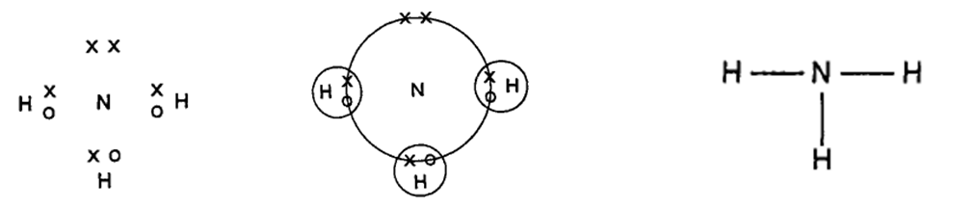
Different types of substance have different properties because of differences in the forces between the particles from which they are made. Molecular compounds are gases, liquids or solids, which have relatively, _____ melting points and boiling points and do not conduct electricity. This is because:
• the forces between the molecules (intermolecular forces) are ________ ; and
• the molecules do not carry an overall electric charge.

Diamond and graphite (forms of carbon) and silicon dioxide (silica) are ________ covalent structures of atoms. Because of the large number of ___________ covalent bonds in their structures, they have very ________ melting points. In ____________ each carbon atom forms four covalent bonds in a rigid, giant covalent structure. In ____________ each carbon atom forms three covalent bonds and the carbon atoms form layers, which are free to slide over each other. In graphite there are free electrons, which allow graphite to conduct electricity.

Ionic compounds are held together by _________ forces of attraction between oppositely charged ions. This is the ionic bond. Ionic compounds form regular structures (giant ionic lattices) in which the __________ forces between oppositely charged ions result in these compounds having _______ melting points and high boiling points. When they are melted or dissolved in water, ionic compounds conduct electricity because the ions are free to move.

Metals consist of __________ structures of positive ions surrounded by a ‘sea’ of delocalised electrons from the outer shell of the atom. These electrons:
• hold the atoms together in a regular structure;
• allow the atoms to slide over each other; and
• allow the metal to conduct electricity.

12. The reaction between magnesium and chlorine forms the ionic compound magnesium chloride, MgCl₂.
(a) By reference to electrons, describe how magnesium and chlorine atoms form magnesium
chloride.
.......................................................................................................................................................
.......................................................................................................................................................
.......................................................................................................................................................
....................................................................................................................................................... (3)

(b) Oxidation occurs in this reaction. Identify the substance that is oxidised in the reaction, giving a reason for your choice.
Substance oxidised ......................................................................................................................
Reason ........................................................................................................................................ (2)

(c) Explain why magnesium chloride has a high melting point.
......................................................................................................................................................
......................................................................................................................................................
......................................................................................................................................................
...................................................................................................................................................... (3)

13. Explain why the melting point of magnesium oxide is much higher than that of sodium chloride.
.......................................................................................................................................................
.......................................................................................................................................................
.......................................................................................................................................................
....................................................................................................................................................... (2)

14. Ammonia is a covalent compound with a simple molecular structure. It is a gas at room temperature.
- Explain why ammonia has a low boiling point.
.......................................................................................................................................................
.......................................................................................................................................................
.......................................................................................................................................................
....................................................................................................................................................... (3)
- Draw a dot and cross diagram to show the structure of ammonia.
(2)

15. Nylon has a molecular structure. Use words from the box to complete the sentences
below. Each word may be used once, more than once or not at all.
ions high low
molecules strong weak

Nylon has a ......................................... melting point. This is because there are.............................. forces between the ......................................... that make up the structure. (3)

16. Hydrogen chloride has a low boiling point. Highlight the correct statement to show the reason for this.
The covalent bonds are strong
The covalent bonds are weak
There are weak forces between the ions
There are weak forces between the molecules (1)

17. The diagrams show the structures of diamond and graphite. They are different structural forms of the element carbon.
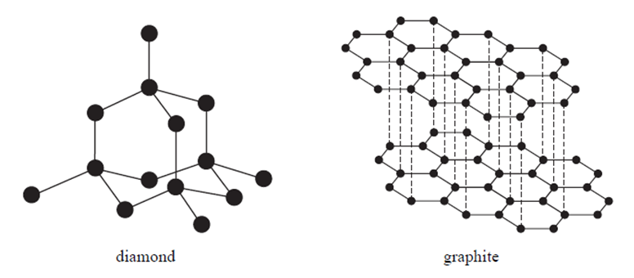
(a) What type of structure are both diamond and graphite? ...................................................... (1)
(b) Diamond has a high sublimation temperature. Explain why.
.....................................................................................................................................................
.....................................................................................................................................................
.....................................................................................................................................................
.................................................................................................................................................... (3)
(c) Graphite can be used as a lubricant. Explain why.
....................................................................................................................................................
....................................................................................................................................................
.................................................................................................................................................... (2)

(d) During the twentieth century another structural form of carbon was discovered. In this structural form the molecules have the formula C₆₀ and are shaped like footballs.  (i) C₆₀ has a much lower sublimation temperature than diamond. Suggest why. | 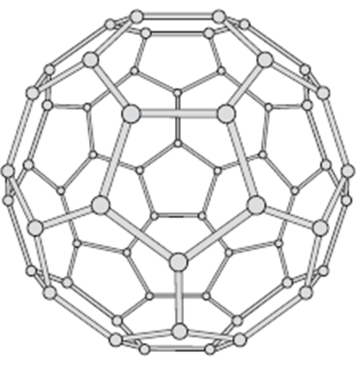
…………………………………………………………………………………………………………………..
…………………………………………………………………………………………………………………..
………………………………………………………………………………………………………………….
……………………………………………………………………………………………………………….... (3)
(ii) Would you expect C₆₀ to act as a lubricant? Explain your answer.
…………………………………………………………………………………………………………………..
…………………………………………………………………………………………………………………..
………………………………………………………………………………………………………………….
……………………………………………………………………………………………………………….... (2)
18. | 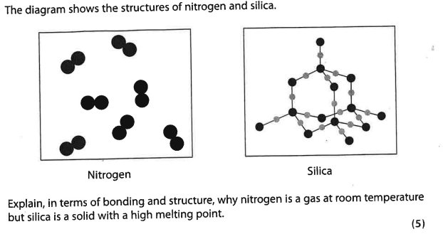
Nitrogen ……………………………………………………………………………………………………..
…………………………………………………………………………………………………………………..
………………………………………………………………………………………………………………….
………………………………………………………………………………………………………………....
Silica …… ……………………………………………………………………………………………………..
…………………………………………………………………………………………………………………..
………………………………………………………………………………………………………………….
………………………………………………………………………………………………………………....

19. (a) What are ions?

(b) What holds the atoms together in covalent molecules?

(c) What happens to electrons during ionic bonding?

(d) Name and describe the type of bonding that you would expect to find in these substances:
i) oxygen

ii) sodium chloride

20. | Match the statement to the correct sentence:  